**SQL Commands**

The **SQL** commands are mainly categorized into four categories as:

1. **DDL** – Data Definition Language
2. **DML** – Data Manipulation Language
3. **DQL** – Data Query Language
4. **TCL** – Transaction Control Language

**1. DDL(Data Definition Language) :**

DDL or Data Definition Language actually consists of the SQL commands that can be used to define the database schema. It simply deals with descriptions of the database schema and is used to create and modify the structure of database objects in the database.

**Examples of DDL commands:**

**(a)** [**CREATE**](https://www.geeksforgeeks.org/sql-create/) – is used to create the database or its objects (like table, index, function, views, store procedure and triggers).

Example: CREATE database employees;

CREATE TABLE department (dep_id int(11), dep_name varchar(20), dep_location varchar(15));



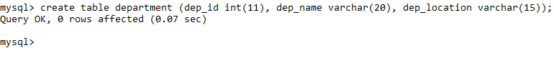

**(b)** [**DROP**](https://www.geeksforgeeks.org/sql-drop-truncate/) – is used to delete objects from the database.

Example: DROP table employees;

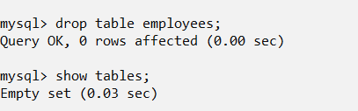

**(c)** [**ALTER**](https://www.geeksforgeeks.org/sql-alter-add-drop-modify/)- is used to alter the structure of the database.

Example: ALTER TABLE employees add column (address varchar(30));

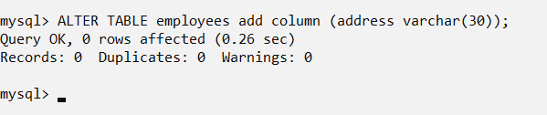

**(d)** [**TRUNCATE**](https://www.geeksforgeeks.org/sql-drop-truncate/)–is used to remove all records from a table, including all spaces allocated for the records are removed.

Example: TRUNCATE employees;

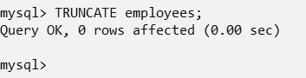

**(e)** [**COMMENT**](https://www.geeksforgeeks.org/sql-comments/) –is used to add comments to the data dictionary.

Example: ALTER TABLE employees

COMMENT “This is Employees Database.”;

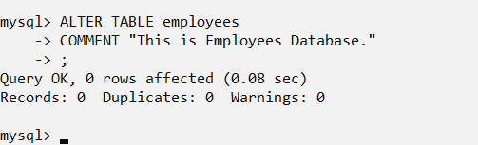

**(f)** [**RENAME**](https://www.geeksforgeeks.org/sql-alter-rename/) –is used to rename an object existing in the database.

Example: RENAME TABLE employees TO emp;



**2. DML (Data Manipulation Language) :**

The SQL commands that deals with the manipulation of data present in the database belong to DML or Data Manipulation Language and this includes most of the SQL statements.

**Examples of DML:**

**(a)** [**INSERT**](https://www.geeksforgeeks.org/sql-insert-statement/) – is used to insert data into a table.

Example: INSERT INTO employees VALUES (69325, 'JOHN', 'CLERK', 68832, '1992- 01-23', 1350.0, 0.0, 1001);

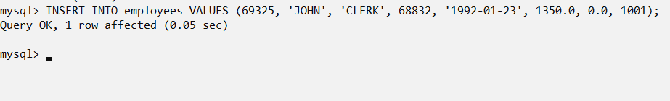

**(b)** [**UPDATE**](https://www.geeksforgeeks.org/sql-update-statement/) – is used to update existing data within a table.

Example: UPDATE employees

SET salary = '1380' WHERE emp_id = 69325;

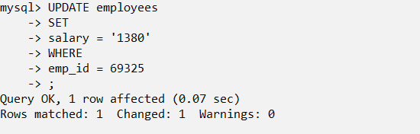

**(c)** [**DELETE**](https://www.geeksforgeeks.org/sql-delete-statement/) – is used to delete records from a database table.

Example: DELETE FROM employees WHERE emp_id = 69325;

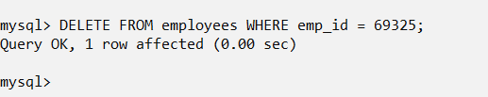

**3. DQL (Data Query Language) :**

DML statements are used for performing queries on the data within schema objects. The purpose of DQL Command is to get some schema relation based on the query passed to it.

**Example of DQL:**

**(a)** [**SELECT**](https://www.geeksforgeeks.org/sql-select-clause/) – is used to retrieve data from the database.

Example: SELECT * FROM employees;

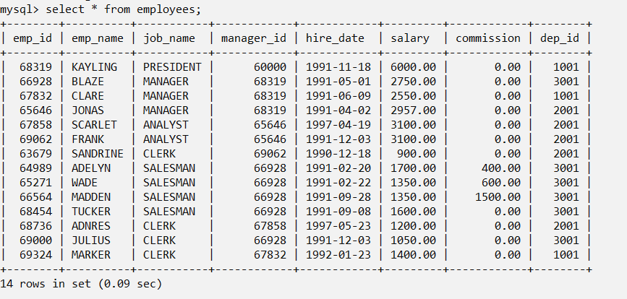

**4. TCL (Transaction Control Language) :**

TCL commands deals with the [transaction within the database](https://www.geeksforgeeks.org/sql-transactions/).

**Examples of TCL commands:**

**(a) COMMIT**– commits a Transaction.

Example: COMMIT;

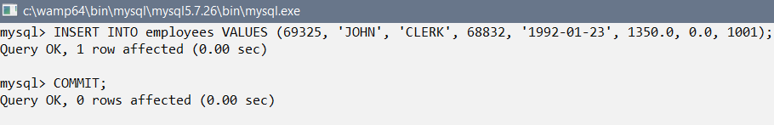

**(b) SAVEPOINT**–sets a save point within a transaction.

Example : SAVEPOINT <savepoint_name>;

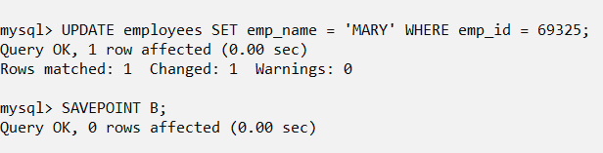

**(c)** [**ROLLBACK**](https://www.geeksforgeeks.org/sql-transactions/)– rollbacks a transaction in case of any error occurs.

Example: ROLLBACK TO <savepoint_name>;



**Some other Basic Commands**

**1. SHOW :** It is used to view the contents of databases.

Example : SHOW databases;

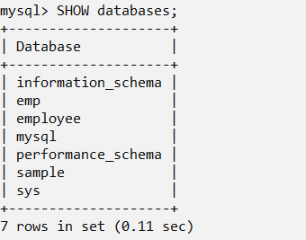

SHOW tables;

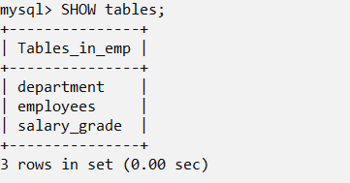

**2. USE :** It is used to use the desired database.

Example : USE emp;



**3. DESC :** It is used to view the description of any table.

Examole : DESC employees;

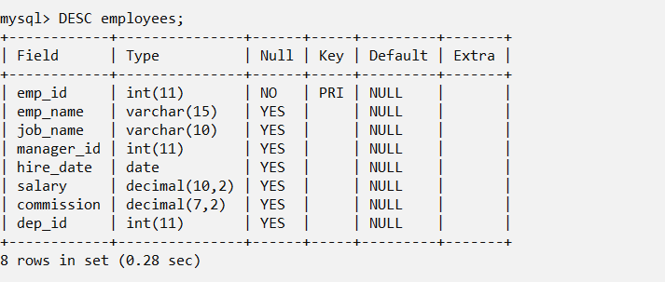

**4. SOURCE :** It is used to import any database.

Example : SOURCE c:\emp_employees.sql;

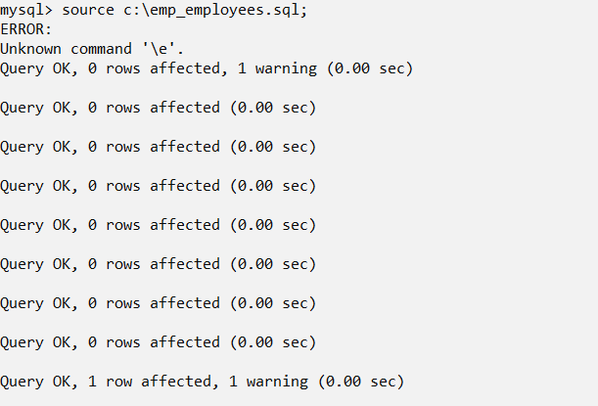

**Employee Database**

Structure of Employee Database

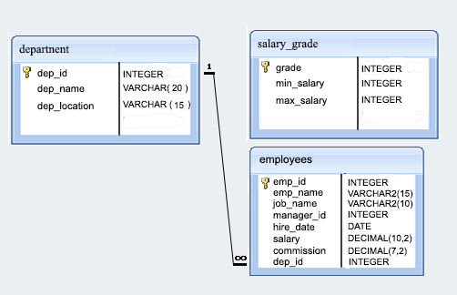

**Task - 1**

**Write a query in SQL to display all the information of the employees.**

**Command:** SELECT * FROM employees;

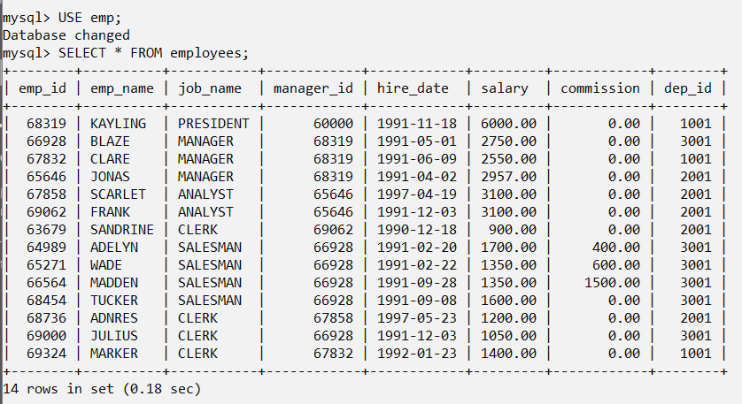

**Task - 2**

**Write a query in SQL to find the salaries of all employees.**

**Command:** SELECT salary FROM employees;

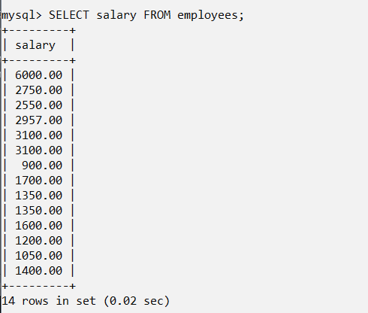

**Task - 3**

**Write a query in SQL to display the unique designations for the employees.**

**Command:** SELECT DISTINCT job_name FROM employees;

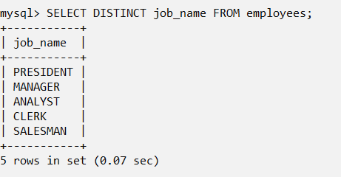

**Task - 4**

**Write a query in SQL to list the emp_name and salary is increased by 15% and expressed as no.of Dollars.**

**Command:** SELECT emp_name, CONCAT(”$”,1.15*salary) FROM employees;

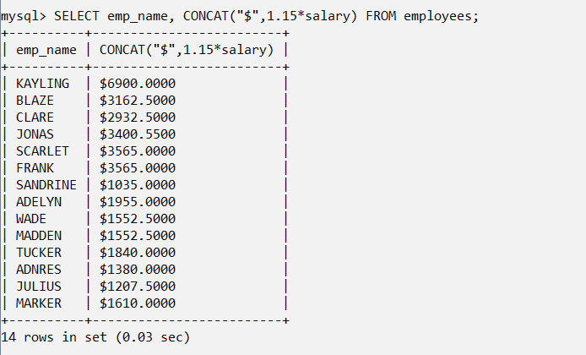

**Task - 5**

**Write a query in SQL to produce the output of employees name and job name as a format of "Employee & Job".**

**Command:** SELECT emp_name,job_name AS “Job” FROM employees;

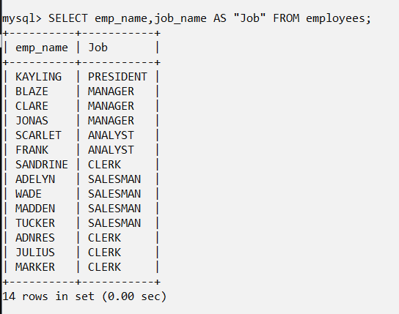

**Task - 6**

**Write a query in SQL to produce the output of employees as follows Employee JONAS(manager).**

**Command:** SELECT CONCAT(emp_name,”(”,job_name,”)”) FROM employees;

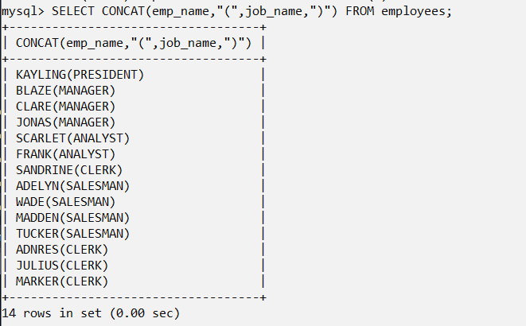

**Task - 7**

**Write a query in SQL to list the employees with Hire date in the format like February 22, 1991.**

**Command:** SELECT emp_id, emp_name, salary, DATE_FORMAT(hire_date,”%M %d,%y”) FROM employees;

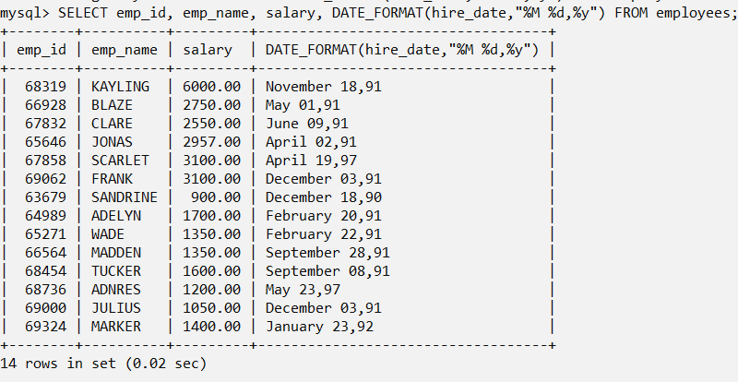

**Task - 8**

**Write a query in SQL to count the no. of characters without considering the spaces for each name.**

**Command:** SELECT LENGTH(TRIM(emp_name)) FROM employees;

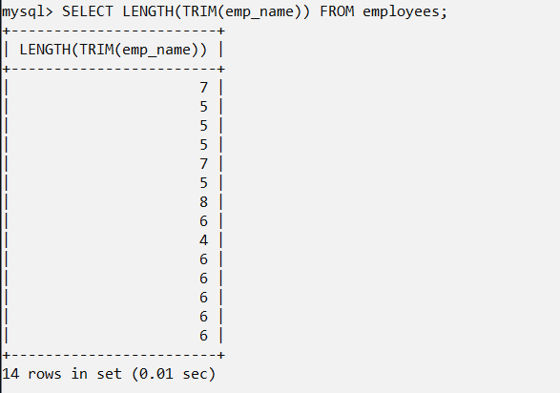

**Task - 9**

**Write a query in SQL to list the emp_id,salary, and commission of all the employees.**

**Command:** SELECT emp_id,salary,commission FROM employees;

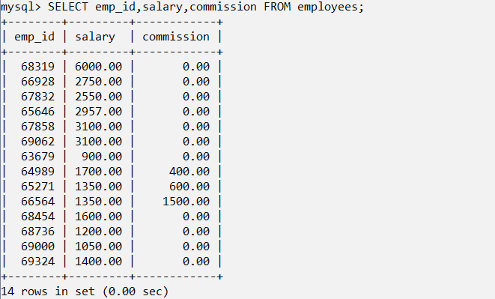

**Task - 10**

**Write a query in SQL to display the unique department with jobs.**

**Command:** SELECT DISTINCT dep_id,job_name FROM employees;

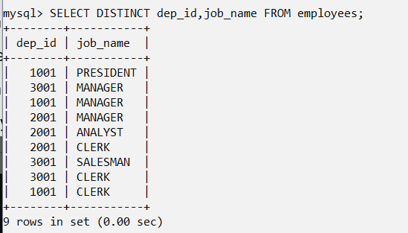

**Task - 11**

**Write a query in SQL to list the employees who does not belong to department 2001.**

**Command :** SELECT * FROM employees WHERE dep_id NOT IN (2001);

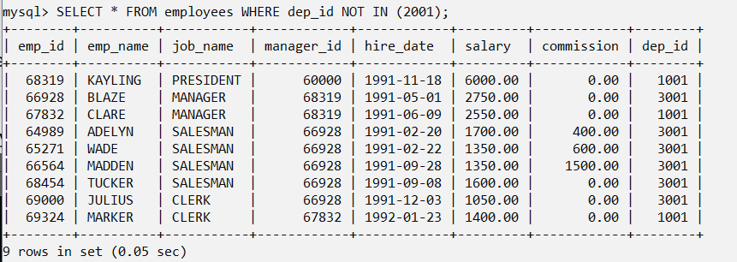

**Task - 12**

**Write a query in SQL to list the employees who joined before 1991.**

**Command :** SELECT * FROM employees WHERE hire_date<(“1991-01-01”);

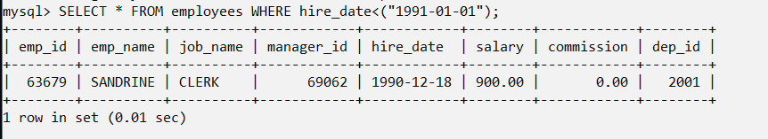

**Task - 13**

**Write a query in SQL to display the average salaries of all the employees who works as ANALYST.**

**Command** : SELECT AVG(salary) FROM employees WHERE job_name=”ANALYST”;

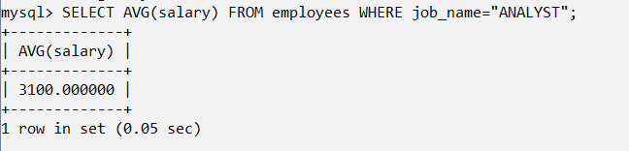

**Task - 14**

**Write a query in SQL to display the details of the employee BLAZE.**

**Command :** SELECT * FROM employees WHERE emp_name=”BLAZE”;

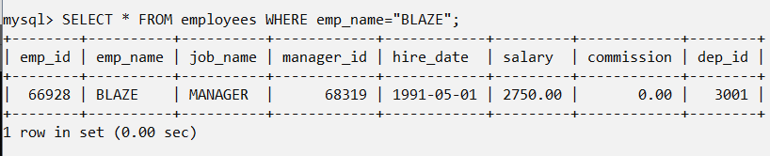

**Task - 15**

**Write a query in SQL to display all the details of the employees whose commission is more than their salary.**

**Command :** SELECT * FROM employees WHERE commission>salary;

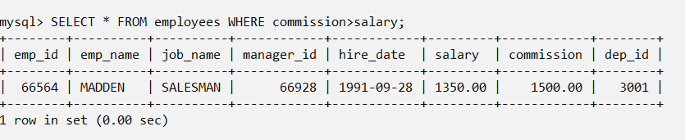

**Task - 16**

**Write a query in SQL to list the employees whose salary is more than 3000 after giving 25% increment.**

**Command :** SELECT * FROM employees WHERE (1.25*salary>3000);

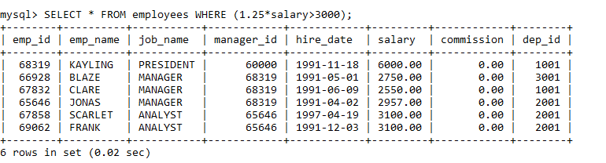

**Task - 17**

**Write a query in SQL to list the name of the employees, those having six characters to their name.**

**Command :** SELECT emp_name FROM employees WHERE length(emp_name)=6;

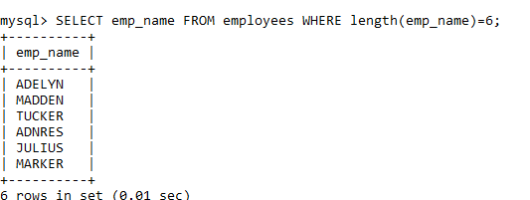

**Task - 18**

**Write a query in SQL to list the employees who joined in the month January**.

Command : SELECT * FROM employees WHERE (date_format(hire_date,”%m”))=1;

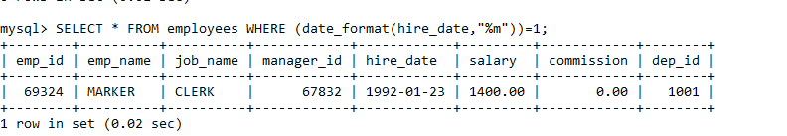

**Task - 19**

**Write a query in SQL to list the name of employees and their manager separated by the string 'works for'.**

**Command :** SELECT CONCAT (e.emp_name,” works for ”,m.emp_name) as “employees” FROM employees e, employees m WHERE e.manager_id=m.emp_id;

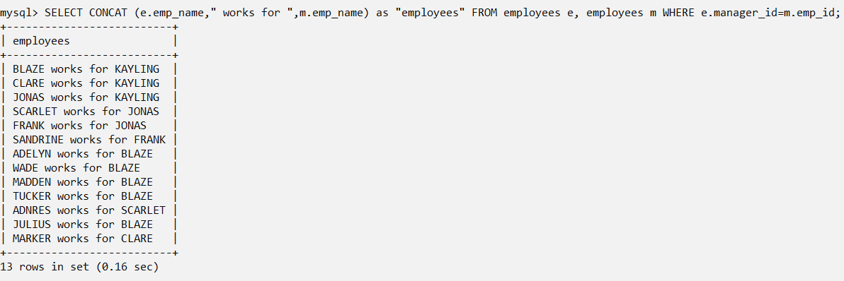

**Task - 20**

**Write a query in SQL to list all the employees whose designation is CLERK.**

**Command** : SELECT * FROM employees WHERE job_name=”CLERK”;

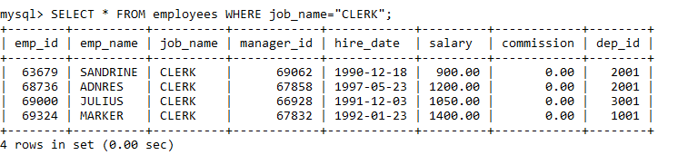

**Task – 21**

**Write a query in SQL to list the employees whose experience is more than 27 years.**

**Command :** SELECT *

FROM employees

WHERE EXTRACT(YEAR

FROM age(CURRENT_DATE, hire_date)) > 27;

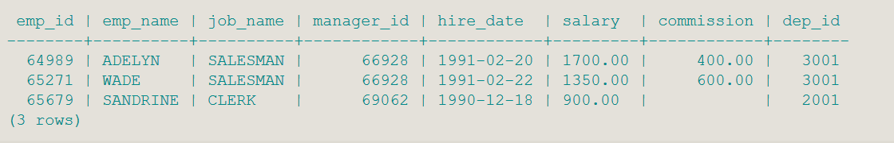

Task - 22

**Write a query in SQL to list the employees whose salaries are less than 3500.**

**Command :** SELECT *

FROM employees

WHERE salary <3500;

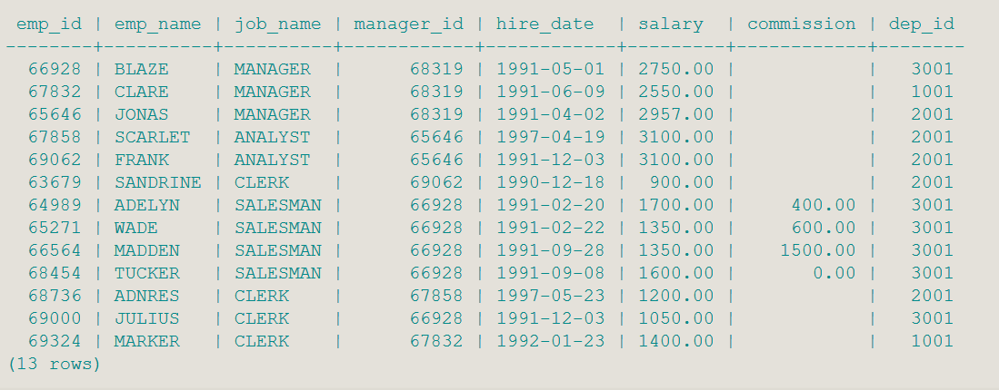

**Task - 23**

**Write a query in SQL to list the name, job_name, and salary of any employee whose designation is ANALYST.**

**Command :** SELECT emp_name,

job_name,

salary

FROM employees

WHERE job_name = 'ANALYST';

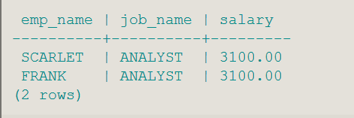

**Task - 24**

**Write a query in SQL to list the employees who have joined in the year 1991.**

**Command :** SELECT *

FROM employees

WHERE to_char(hire_date,'YYYY') = '1991';

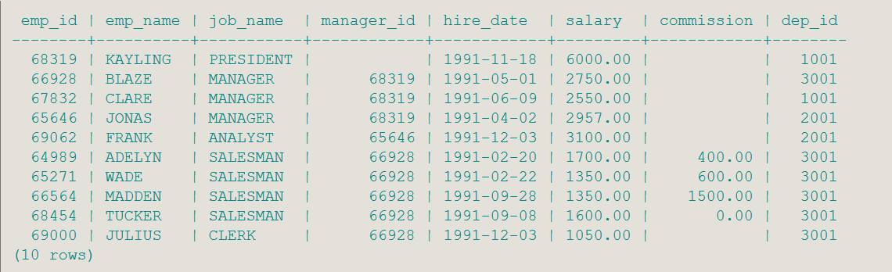

**Task - 25**

**Write a query in SQL to list the name, id, hire_date, and salary of all the employees joined before 1 apr 91.**

**Command :** SELECT e.emp_id,

e.emp_name,

e.hire_date,

e.salary

FROM employees e

WHERE hire_date <'1991-04-01';

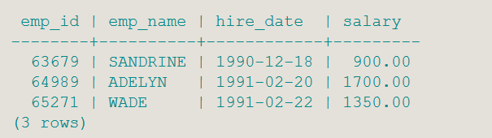

**Task - 26**

**Write a query in SQL to list the employee name, and job_name who are not working under a manager.**

**Command :** SELECT e.emp_name,

e.job_name

FROM employees e

WHERE manager_id IS NULL;

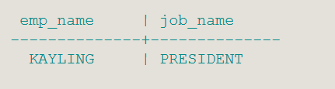

**Task - 27**

**Write a query in SQL to list all the employees joined on 1st may 91.**

**Command :** SELECT *

FROM employees

WHERE hire_date = '1991-05-01';

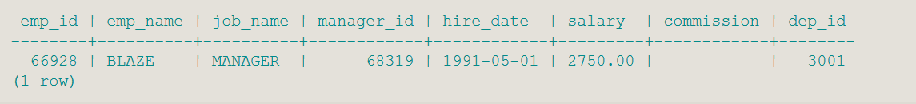

**Task - 28**

**Write a query in SQL to list the id, name, salry, and experiences of all the employees working for the manger 68319.**

**Command :** SELECT emp_id,

emp_name,

salary,

age(CURRENT_DATE, hire_date) "Experience"

FROM employees

WHERE manager_id=68319;

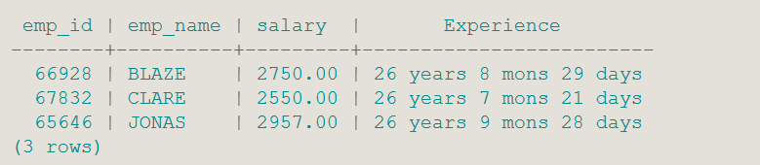

**Task - 29**

**Write a query in SQL to list the id, name, salary, and experience of all the employees who earn more than 100 as daily salary.**

**Command :** SELECT emp_id,

emp_name,

salary,

age(CURRENT_DATE, hire_date) "Experience"

FROM employees

WHERE (salary/30)>100;

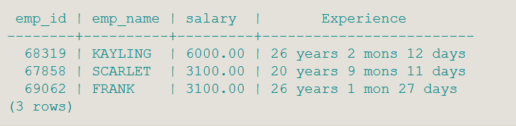

**Task - 30**

**Write a query in SQL to list the employees who are retiring after 31-Dec-99 after completion of 8 years of service period.**

**Command :** SELECT emp_name

FROM employees

WHERE hire_date + interval '96 months' > '1999-12-31';

